English Language Summer Club!

Join our English Language Summer Club for one – four weeks and keep your reading, writing, listening and speaking skills up over the summer – don’t slip back….stay on track !

8.30 a.m. – 1.00 p.m. (Please bring a packed lunch and water bottle)

- All our courses offer direct instruction in small groups of maximum 12 students
- Students will work in small groups on projects which aim to develop writing and critical reading skills
- Creative Writing, Language Development, Drama and Reading aloud all form part of our Workshops
- Choose from either; Basic Language Skills or Writers Workshop (see schedules below)
- Flexible dates with intakes every Monday
- Classes will take place at AClass Academy, Pembroke

7- 10 Year Olds; Writers Workshop; From Hamlet to Harry Potter
Writers Workshop | Monday | Tuesday | Wednesday | Thursday | Friday
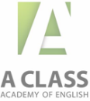 | Brainstorming and getting ideas | Writers workshop;  The traits of good writing | The Grammar of the Greats ; Sentence Modelling based on YOUR favourite authors | Drama; Get some inspiration from great dramatists and a chance to perform a short piece | Letter Writing; Formal and Informal Letters
 | B | R | E | A | K
 | Expanding your vocabulary; ways of collecting words | Looking at model texts; discussion based activities | Writers workshop;  Sentence Fluency | Writing a great story; ways of starting and ending, how to structure a plot and raise suspense. | Feedback Session;  Presentations
4- 6 Year Olds; Key Language Skills
Basic Skills | Monday | Tuesday | Wednesday | Thursday | Friday
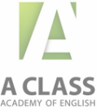 | Phonics  Read Aloud Session | Read Aloud Session  Computer Session; Star Fall | English Through Songs | Phonics  Games with new words; snap/ Pictionary | Computer Session; Star Fall
 | B | R | E | A | K
 | Expanding your vocabulary; basic verbs | Expanding your vocabulary; basic verbs | Sentence Fluency | Expanding your Vocabulary;  Sight words | Listen to a story and act it out!

Registration Form
To register your interest; please indicate with a tick which week/s you are interested in attending;

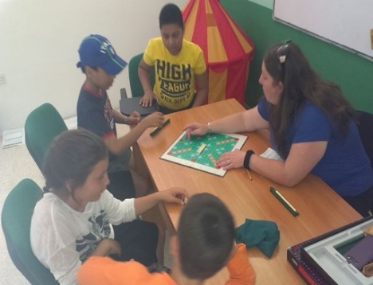
- 4th July
- 11th July
- 18th July
- 25th July
- 1st August
- 8th August
- 15th August
- 22nd August
- 29th August
- 5th September

Name and Surname of Child ; ___________________________
Home Address; __________________________________________________________________________________________________________________________________________Age and Date of Birth; _______________________________________________
Current Class (if applicable)_________________________________________
Nationality; ________________________________Male or Female? ______
Telephone; __________________________ Mobile; ______________________
Next of kin (emergency number); ____________________________________
Email address; _______________________________________________________

Course Fees

Price per week is €165

*Parents kindly note; there will be no refunds given for missed days or public holidays.

Summer Camp Disclaimer
In order to be able to offer a course a minimum number of six applicants per class is required, if this is not reached we reserve the right not to offer the course on that week.

